1.Given an array arr[] of the positive integers of size N, the task is to find the largest element on the left side of each index which is smaller than the element present at that index. Note: If no such element is found then print -1.

**import** ava.util.*;

**class** GFG{

//Function to find the

//Largest element before

//every element of an array

**static void** findMaximumBefore(**int** arr[], **int** n){

// Loop to iterate over every

// element of the array

**for** (**int** i = 0; i<n; i++) {

**int** currAns = -1;

// Loop to find the maximum smallest

// number before the element arr[i]

**for** (**int** j = i - 1; j>= 0; j--) {

**if** (arr[j] >currAns&&

arr[j] <arr[i]) {

currAns = arr[j];

}

}

System.***out***.print(currAns+" ");

}

}

**public static void** main(String[] args)

{

**int** n;

Scanner s = **new** Scanner(System.***in***);

System.***out***.print("Enter no. of elements you want in array:");

n = s.nextInt();

**int** arr[] = **newint**[n];

System.***out***.println("Enter all the elements:");

**for**(**int** i = 0; i<n; i++)

{

arr[i] = s.nextInt();

}

**int** n1 = arr.length;

// Function Call

*findMaximumBefore*(arr, n1);

}

}

OUTPUT:  
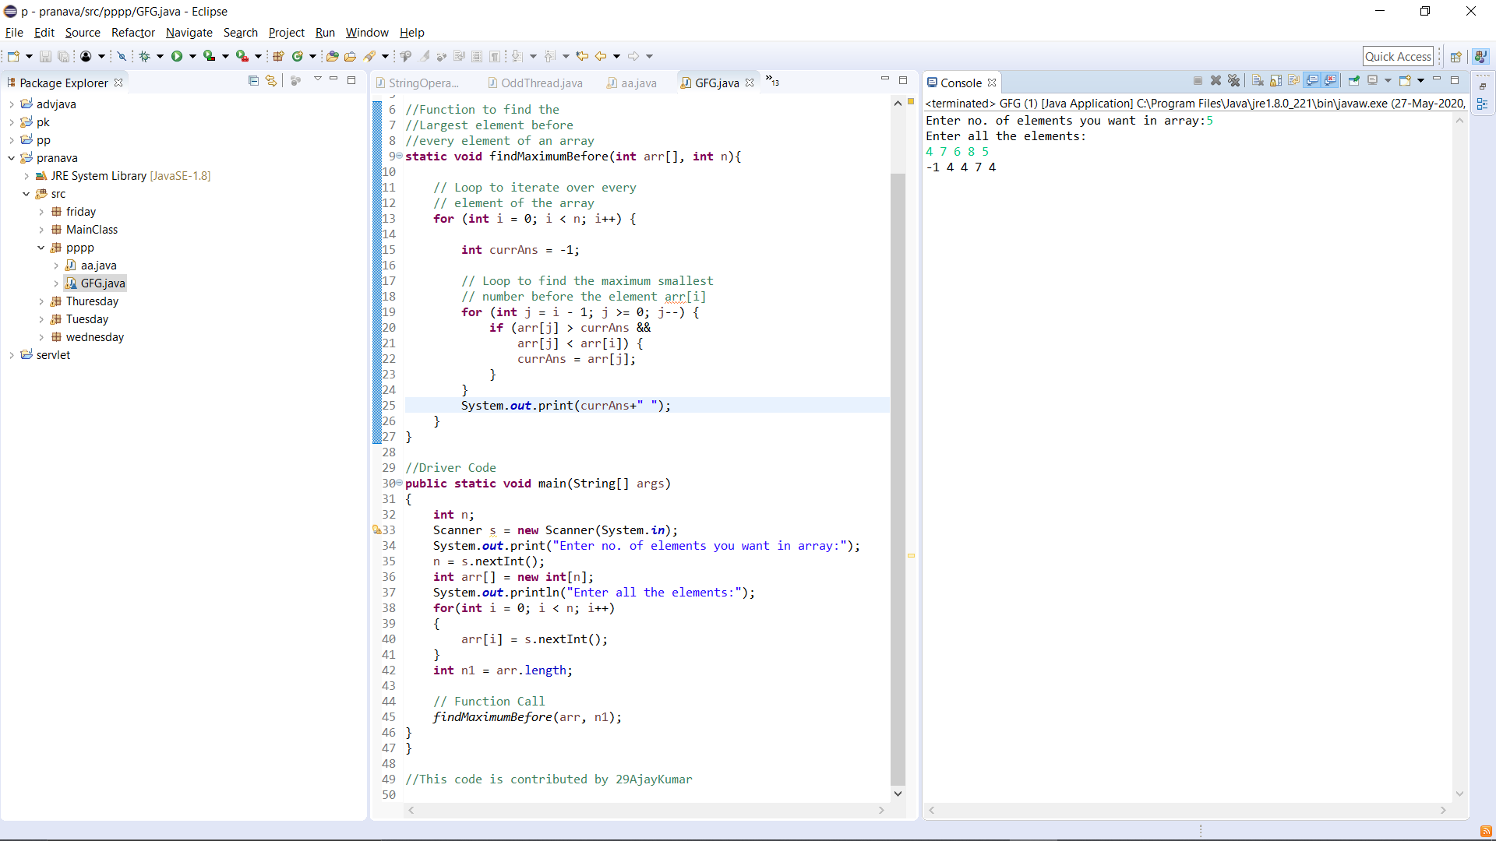

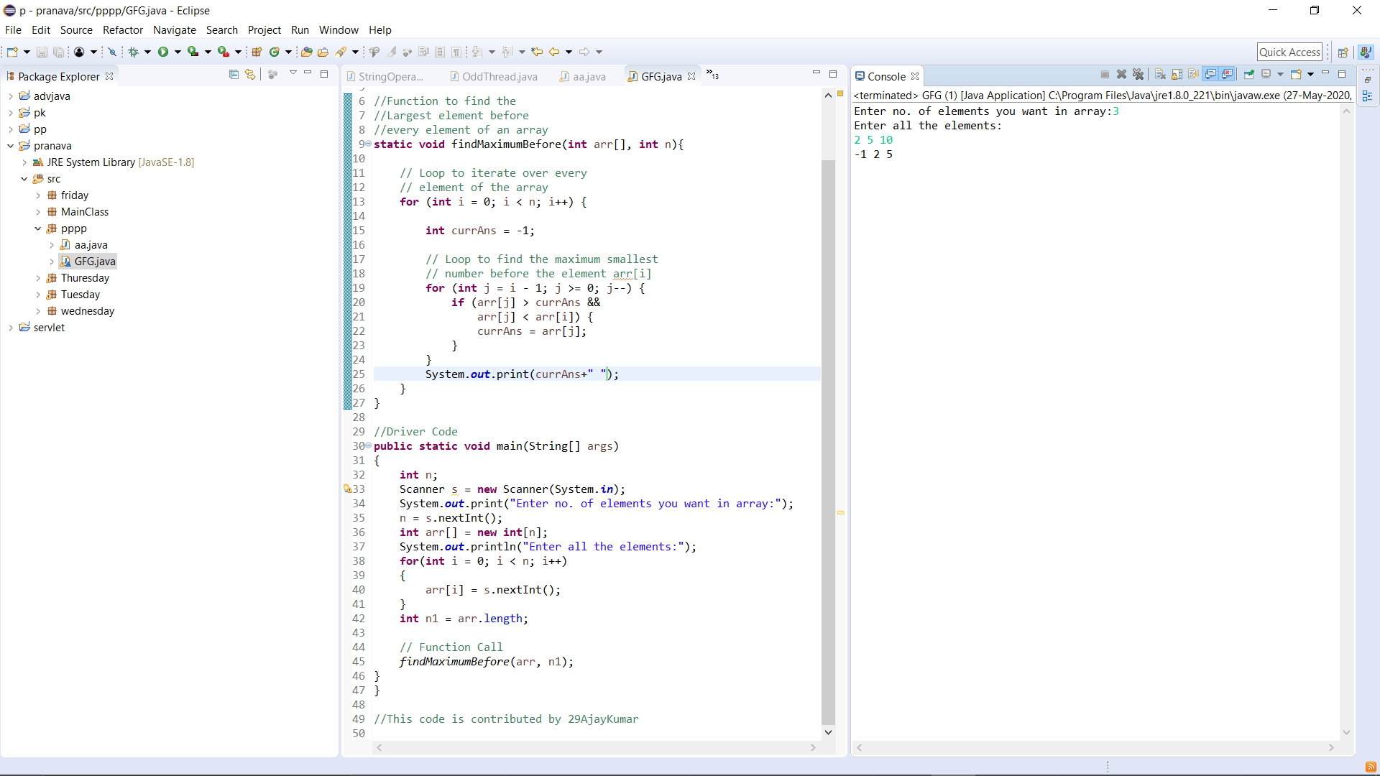

Write a Java program to implement Binary Tree using the Linked List

**import** java.util.LinkedList;

**import** java.util.Queue;

**public class** BinaryTree {

//Represent a node of binary tree

**public static class** Node{

**int** data;

Node left;

Node right;

**public** Node(**int**data){

//Assign data to the new node, set left and right children to null

**this**.data = data;

**this**.left = **null**;

**this**.right = **null**;

}

}

//Represent the root of binary tree

**public** Node root;

**public** BinaryTree(){

root = **null**;

}

//insertNode() will add new node to the binary tree

**public void** insertNode(**int** data) {

//Create a new node

Node newNode = **new** Node(data);

//Check whether tree is empty

**if**(root == **null**){

root = newNode;

**return**;

}

**else** {

Queue<Node>queue = **new** LinkedList<Node>();

//Add root to the queue

queue.add(root);

**while**(**true**) {

Node node = queue.remove();

//If node has both left and right child, add both the child to queue

**if**(node.left != **null**&&node.right != **null**) {

queue.add(node.left);

queue.add(node.right);

}

**else** {

//If node has no left child, make newNode as left child

**if**(node.left == **null**) {

node.left = newNode;

queue.add(node.left);

}

//If node has left child but no right child, make newNode as right child

**else** {

node.right = newNode;

queue.add(node.right);

}

**break**;

}

}

}

}

//inorder() will perform inorder traversal on binary search tree

**public void** inorderTraversal(Node node) {

//Check whether tree is empty

**if**(root == **null**){

System.***out***.println("Tree is empty");

**return**;

}

**else** {

**if**(node.left!= **null**)

inorderTraversal(node.left);

System.***out***.print(node.data + " ");

**if**(node.right!= **null**)

inorderTraversal(node.right);

}

}

**public static void** main(String[] args) {

BinaryTreebt = **new**BinaryTree();

//Add nodes to the binary tree

bt.insertNode(1);

//1 will become root node of the tree

System.***out***.println("Binary tree after insertion");

//Binary after inserting nodes

bt.inorderTraversal(bt.root);

bt.insertNode(2);

bt.insertNode(3);

//2 will become left child and 3 will become right child of root node 1

System.***out***.println("\nBinary tree after insertion");

//Binary after inserting nodes

bt.inorderTraversal(bt.root);

bt.insertNode(4);

bt.insertNode(5);

//4 will become left child and 5 will become right child of node 2

System.***out***.println("\nBinary tree after insertion");

//Binary after inserting nodes

bt.inorderTraversal(bt.root);

bt.insertNode(6);

bt.insertNode(7);

//6 will become left child and 7 will become right child of node 3

System.***out***.println("\nBinary tree after insertion");

//Binary after inserting nodes

bt.inorderTraversal(bt.root);

}

}

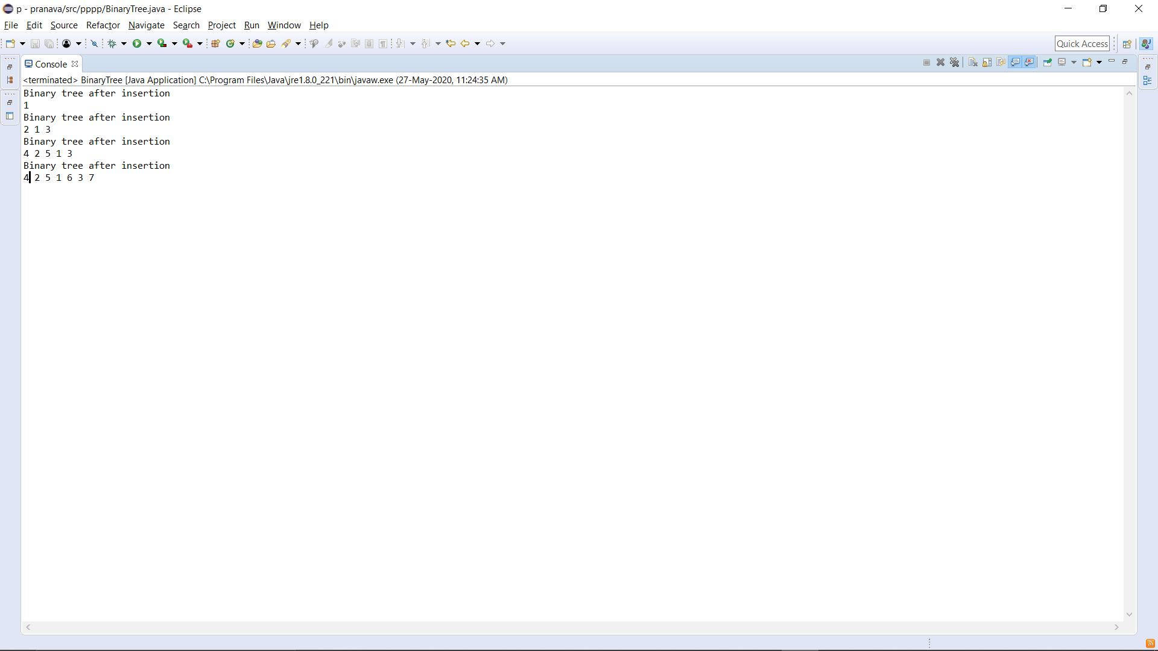 **OUTPUT:**